**《语义网与知识图谱》实验手册**

**实验二 RDF（RDFS）应用二**

目的：

1. 理解语义网资源描述语言；
2. 掌握RDF(S)的使用。

内容：

**【习题1】** Translate the culinary-allergic example ontology presented in follow into RDF/XML syntax.

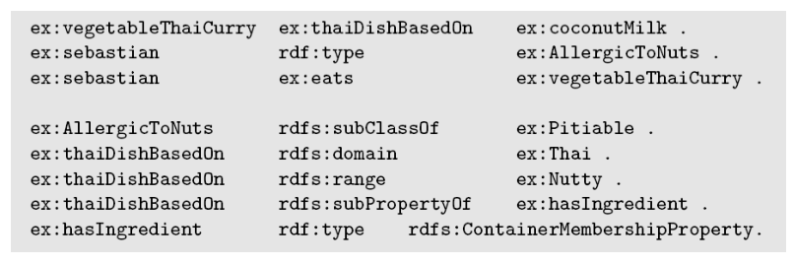

|  |
| --- |
| <?xml version=”1.0”?>  <rdf:RDF xmlns:rdf=”http://www.w3.org/1999/02/22-tdf-syntax-ns#”  xmlns:rdfs=”http://www.w3.org/2000/01/rdf-schema#”  xlmns:ex=”not given”>  <rdf:Description rdf:about=”vegetableThaiCurry”>  <ex:thaiDishBasedOn>coconutMilk</ex:thaiDishBasedOn>  </rdf:Description>  <rdf:Description rdf:about=”sebastian”>  <rdf:type>AllergicToNuts</rdf:type>  </rdf:Description>  <rdf:Description rdf:about=”sebastian”>  <ex:eats>vegetableThaiCurry</ex:eats>  </rdf:Description>  <rdf:Description rdf:about=”AllergicToNuts”>  <rdfs:subClassOf>Pitiable</rdfs:subClassOf>  </rdf:Description>  <rdf:Description rdf:about=”thaiDishBasedOn”>  <rdfs:domain>Thai</rdfs:domain>  </rdf:Description>  <rdf:Description rdf:about=”thaiDishBasedOn”>  <rdfs:range>Nutty</rdfs:range>  </rdf:Description>  <rdf:Description rdf:about=”thaiDishBasedOn”>  <rdfs:subPropertyOf>hasIngredient</rdfs:subPropertyOf>  </rdf:Description>  <rdf:Description rdf:about=”hasIngredient”>  <rdf:type>ContainerMembershipProperty</rdf:type>  </rdf:Description>  </rdf:RDF> |

**【习题2】** Decide whether the following propositions can be satisfactorily modeled in RDFS and, if so, give the corresponding RDF(S) specification.

* Every pizza is a meal.
* Pizzas always have at least two toppings.
* Every pizza from the class PizzaMargarita has a Tomato topping.
* Everything having a topping is a pizza.
* No pizza from the class PizzaMargarita has a topping from the class Meat.
* “Having a topping” is a containedness relation.

|  |
| --- |
| **- Every pizza is a meal.**  Can be modeled.  <rdf:Description rdf:about=”pizza”>  <rdfs:subClassOf>meal</rdfs:subClassOf>  </rdf:Description>  **- Pizzas always have at least two toppings.**  Can’t be modeled.  **- Every pizza from the class PizzaMargarita has a Tomato topping.**  Can be modeled.  <rdf:Description rdf:about=”pizzaFromtheClassPizzaMaragarita ”>  <ex:has>TomatoTopping</ex:has>  </rdf:Description>  **- Everything having a topping is a pizza.**  (是pizza having topping, so, having topping 的domain 是 pizza)  Can be modeled.  <rdf:Description rdf:about=”HavingTopping”>  <rfds:domain>pizza</rfds:domain>  <rfds:range>topping</rfds:range>  </rdf:Description>  **- No pizza from the class PizzaMargarita has a topping from the class Meat.**  Can’t be modeled.  **- “Having a topping” is a containedness relation.**  Can be modeled.  <rdf:Description rdf:about=”HavingATopping”>  <rfd:type>subClassOf</rdf:type>  </rdf:Description> |

【**习题3**】 Model the following sentences in XML:

1. Mary is a woman.

2. Every mother is a woman.

3. Mary is John’s wife.

4. Mothers are women who are also parents.

5. At least one child of a grandparent has also a child.

|  |
| --- |
| <?xml version=”1.0”?>  <rdf:RDF  xmlns:rdf=”http://www.w3.org/1999/02/22-tdf-syntax-ns#”  xmlns:ex=”not given”>  **(- Mary is a woman.)**  <rdf:Description rdf:about=”Mary”>  <rdf:type rdf:resource=”woman”/>  </rdf:Description>  **(- Every mother is a woman.)**  <rdf:Description rdf:about=”mother”>  <rdf:type rdf:resource=”woman”/>  </rdf:Description>  Or *not sure*  <rdf:Description rdf:about=”mother”>  <rdfs:subClassOf> woman</rdfs:subClassOf>  </rdf:Description>  **(- Mary is John’s wife.)**  <rdf:Description rdf:about=”Mary”>  <rdf:type rdf:resource=”John’s wife”/>  </rdf:Description>  **(- Mothers are women who are also parents.)**  <rdf:Description rdf:about=”mothers”>  <rdf:type rdf:resource=”women”/>  <rdf:type rdf:resource=”parents”/>  </rdf:Description>  **(- At least one child of a grandparent has also a child.)**  <rdf:Description rdf:about=”One child of a grandparent”>  <ex:has rdf:resource=”a child”/>  </rdf:Description> |

【**习题4**】Model the sentences from Exercise 3 in RDF graph.

|  |
| --- |
|  |